Ghazian Progress Report

York University, Toronto, ON

Spring 2019

**The microclimatic effects on vertebrate interactions with foundation plant species.**

**What about the scaling to macroclimate**

**Micro to macroclimatic scaling effects on foundation plant species interactions with vertebrate protégé species.**

**Something like that?**

**Also – this makes me think – you need to talk to Jenna ASAP – she has a sweet, simple protocol for pan trapping that gives your inverts tooo**

**THEN project is the above title but you have ‘animals’ instead of verts only and snap it is like a WHOLE other level higher. HONEST pan traps not hard. BE SO COOL.**

**Examination Committee:**

Dr. Christopher Lortie

Dr. Suzanne MacDonald

Table 1. MSc research timeline.

|  |  |  |
| --- | --- | --- |
| Chapter | Title | timeline |
| 1 | **A picture is worth a thousand hours: a systematic review of camera trap papers to test for reported sampling effort.** | Full-text articles assessed for eligibility.  Data extraction complete June 2019.  Chapter 1 draft October 2019. |
| 2 | **Survey of plant-animal interactions and microclimate.** | Field season will run 15/05/2019-15/06/2019.  Some statistical analyses have been done for previous year’s macro and micro?climate data.  Camera trap data will be extracted by Dec 2019.  Draft by May 2020 |
| 3 | **The importance of microclimatic refuges in deserts via shelters.** | Field season 2019.  Shelter design is complete.  Shelters will be built and deployed in the field May 2019.  Shelters will be re-visited August 2019 and data will be extracted.  Analysis and writing should finish July 2020. |

SNAP _ HOTTER TITLES MAKE ALL THE DIFF

**Background**

The stress-gradient-hypothesis (SGH) proposes a switch in the relative frequency of competition to facilitation with increasingly stressful environmental conditions (citation). This hypothesis sparked the interest of many for examining positive interactions (Citation to reviews such as McIntire and Fajardo facilitation review in J Ecol and the He at al Eco lets papers). Since, various studies have focused on positive interactions in harsh environments, including arid ecosystems2–4. Facilitation is a type of positive interaction where one interacting species benefits whilst none are harmed5. Much of facilitation research is focused on plant-plant interactions6, though the emergence of studies focusing on animal-plant interactions is also observed7,8. CLUNKY – revise not clear on the purpose of this background theory – have it connect to your big idea?

SGH important

We typically measure the positive interaction component in these studies relatively well

BUT we do not measure microclimate or climate that well – ie many papers discuss stress but do not measure or report effectively. SNAP NOW You are set up

Then end this first paragraph with implication – ideally to advance the relative importance in stress and CHANGES in stress with global change, we need to both measure interactions and climate at DIFFERENT SCALES well!!! YES

Foundational plant species or nurse plants are an integral part of facilitation research9. These include shrubs, perennials, trees, or cushion plants that benefit other plants or taxa10 through various mechanistic pathways that include, but are not limited to, seed trapping, abiotic stress amelioration, and soil modification9. An important agent of abiotic stress amelioration is shrub canopy, able to facilitate animals through direct and indirect shelter and refuge effects11,12. Thus, it is understood that foundational plants serve as a great focal point for a variety of studies hoping to examine plant-plant, plant-animal, plant-plant-animal, or plant-animal-animal facilitation in a given ecosystem. MEH – same – FOCUS???

Many facilitation pathways in plant-plant interactions between benefactors and protégé species. Then list them . Them argue that shelter and amelioration THE most common one measured. HOWEVER, there is also the capacity for these same interaction pathways to benefit animals in deserts too – inverts and verts (Citation Lortie et al Functional Ecology paper). Then – you are NOW setting up reader for the punchline – THIS is a research gap – ie how do shelter and refuges common in facilitation literature ALSO influence other taxa. This is important because deserts are home to many rare, endemic species of animals, biodiversity is high in drylands, these systems are under threat and many federally listed endangered species are in deserts including some of the first to ever be listed in the USA, etc… SO we must study.

THEN you now need a third and FINAL general paragraph introducing the LAST big GEAR of your research – MICRO – to MACRO climate and why this important.

Define each.

Explain how each is likely to change

Explain that plants and animals likely experience both scales of change – ie drought at large scales but at MICRO scales because a. animals can cover and b. for plants and animals deserts are extremely hetereogenic at fine scales (citations), we need data at both levels. SNAP…. Set up now for your idea – Climate envelope models are common tools for species to understand how they respond to change and environmental drivers BUT you can not ignore interactions the buffer their tolerances too (citations). PERFECT>…

Carrizo Plain National Monument (35.1914° N, 119.7929° W) is the largest remnant ecosystem of the San Joaquin Desert located in the south-eastern San Louis Obispo Country13. The plain is home to various dominant shrub species such as *Ephedra californica* (Mormon tea) and *Atriplex polycarpa* (saltbush)14. *Ephedra californica* is a well-adapted, slow-growing shrub which spreads colonially in hot deserts15, generally growing in elevations of 200-1200 m. Although severe fires can kill the plant16, it is fairly resistant to moderate fires with the ability to sprout. Ephedra’s high abundance and resilience in this ecosystem makes the perfect plant for facilitation research.

Desertification and arid region expansion is not only prevalent in the Carrizo Monument, but is also a critical global change issue17. The well-being and function of foundation plants species may depend on factors such as in temperature, variability in precipitation, extended drought periods, and radiation 18–20. The changes in the above microclimatic parameters are primarily due to anthropogenic climate change21 that significantly modifies physical and biological systems in all continents22. Climate-driven behavioural plasticity encourages shifts in habitat so behavioural regimes can continue to function23. Thus, closing this research gap by examining behavioural-ecological domains such as movement and spatial pattern, forging and vigilance, social organization, and reproductive behaviour24 is important. I propose that microclimatic parameters, such as temperature and radiation, are able to influence the associational behaviour of vertebrates with shrubs. Particularly, I’m interested in quantifying the extent to which temperature and solar radiation can influence this interaction via camera trapping data.

Camera traps allows researcher to obtain wildlife data with relatively little to no human disturbance25. Studies have explored their use to estimate population size26, examine wildlife behaviour27, and explore activity patterns and habitat use28. Although camera traps have been used to look at animal interactions with plants to an extent29, their use to examine shelter and refuge effects of foundational plants is unique. Despite previous literature’s focus on closing the gaps that exists in photographic rates as an index of density 30, to my knowledge no single study to this date has systematically compiled data from previous research to generate species rarefaction curves based on camera trap sampling effort. This is an important research gap as rarefaction curves can provide insight into the sampling effort required in a given environment to accurately determine species richness.

Crops and plants can act as natural shelters by providing shading effects, reducing wind speed, and decreasing the nearby CO2 concentration31. However, various synthetic shelters can also be designed and deployed in the field to test for their influence on microclimate. Open-top Chambers (OTC) are relatively inexpensive and provide the means to manipulate parameters such as CO2, temperature, soil temperature, solar radiation, and humidity32,33. Yet, a cheaper alternative is UV-permeable Perspex shelters that can be used to increase the temperature, allow airflow, and change radiation intensity and UV permeability. To the best of my knowledge, no experiment has paired Perspex shelters with camera traps and temperature pendants in order to examine the impact of manipulations of the above parameters on animal behaviour. The closest analog is animal monitoring under solar panel arrays 34, but these surveys typically include full light exclosures by the panels. Thus, a field study testing a variety of shelter types can provide more insight into how each can influence the microclimate. This knowledge is key to the better understanding of how natural shelters, such as shrubs, may mediate the impacts of climate change on animals in the near future.

KEEP but reorganize – I think you only need the 3 BIG paragraphs I proposed – those three things are critical to your work… I would cut these other ones from HERE but SAVE in case we need for writing papers later…

**Chapter 1:** **A picture is worth a thousand hours: a systematic review of camera trap papers to test for reported sampling effort.**

**Purpose:** Identify the relevant literature using camera trapping to examine species richness and diversity as an index of sampling effort.

**Questions:** How many hours, days, or months are needed to estimate the species richness and diversity of a given ecosystem using a camera trapping tool? What taxa are usually recorded (i.e. mammals, Aves etc.)? Does the temperature of the study period function as a covariate when predicting species richness?

**Methods: Provide a few sentences of what you did – searched WoS on X date etc…,** The PRISMA diagram (Figure 1) workflow describes the process of this meta-analysis. A citation alert set up on Web of Science with key terms ensures that the review is up to date.

**Preliminary Results:** Studies were selected from a scientific database (Web of Science) using the keywords: Camera Trap* AND Richness*, Camera* Trap* AND Diversity*, and Camera Trap* AND Rarefaction* Curve*. A total of 515 studies were selected, which resulted in 397 studies when duplicates were removed. Many of the papers were either long-term, wildlife monitoring studies or agricultural. However, infrequently there were some studies involving aquatic ecosystems and coral reefs and these were excluded. Other exclusion criteria included non-English, reviews, non-quantitative studies, or focussed on a single species. An entire paper was selected for the analysis if it contained the species richness/diversity and at least some sort of a measurement of time spam (hours, days, months, and/or camera trapping days), in addition to the number of records. If the study reported a measure of temperature, this was recorded; however, most studies did not. Thus, external research needs to be done in order to obtain climate data. THIS is all methods – rewrite and MOVE Up to that section… just list the prelim findings in results only.

**Future Direction:** Currently data are being extracted from 252 full text studies. The aim is to finish this process in May, 2019 and start the statistical analysis. I hope to write the paper by September, 2019.

Papers obtained through database searching (Web of Science) Keywords:

Camera* Trap* AND Richness*, Diversity*, and Rarefaction* Curve*

(n= 515)

(n = 1090)

Full-text articles assessed for eligibility (n = 252)

(n = )

Records after duplicates removed   
(n = 397)

## Identification

Papers obtained from other sources, such as book chapter bibliographies

(n= 0)

## Eligibility

Records excluded for: relevance, review, opinion or idea paper, focus on one spices, qualitative, not English.

Records screened by abstract (n = 397)

## Screening

Full-text articles excluded:

Not reporting richness or diversity, number of records, and any measure of duration.

Include in synthesis

(n = )

Extracted data:

Location (lat, long), duration.hours, duration.months, camera trap days, number of records, animal richness, scientific name, year, number of cameras, number of sites, month of study, type of ecosystem, study design, and some measure of temperature for study period

## Included

Figure 1: PRISMA diagram35 used for camera trapping effort systematic review.

**Chapter 2: Examining plant-animal interactions at a microsite level.**

**Purpose:** To examine whether animal association patterns with shrubs are explained by microsite level fluctuations in temperature and light.

**Question:** To what extent do radiation intensity, air and soil temperature influence the association of vertebrates with foundational plants? How does the strength of this association change as the above microclimatic parameters increase or decrease? Is this association species-specific and does it depend on the animal’s lifestyle?

**Hypotheses and predictions:** Shrubs can act as thermal refuge for many desert animals. As temperature increases, the association for animals such as ectotherms, which rely on the environment for internal temperature regulation, may also increases. Shrubs can also provide shade that can be used by all types of animals (ectotherms or homeotherms) when radiation is at its peak and the animal needs to cool itself.

**Methods:**

Camera trapping will be done in the Spring-Summer of 2019 in the Carrizo National Monument at 2 different sites. Cameras will be moved around to maximize incidents of associational observation. Each camera will be deployed facing a shrub 3 meters away from shrub canopy. The open microsite equivalent will be placed back-to-back with the shrub camera, but evidently recording the open. Cameras will be placed exactly at ground level at any given coordinate and secured using pegs. 2 sets of temperature pendant loggers (one soil and one air) will be placed below the canopy for shrub microsite and 3 meters away from the camera in the open for the open microsite to log temperature and light intensity data in 30 minute intervals. The air pendants will be secured to pegs using zip ties and placed 2-3 cm above ground. Images collected will be saved as Joint Photographic Expert Group (JPEG) format where data such as presence/absence of an animal will be extracted. Video trap data from another lab member’s research (Mario Zuliani) will also be used to further explore and confirm the activity of these vertebrates. Shrub height, length, and width (x, y, and z) dimensions will also be recorded once before and after the study is finished. Soil moisture measurements will be recorded from under the canopy and the open on a daily basis.

**Progress to Date:**

* Carrizo monthly weather data from the year 2018 was retrieved from a nearby satellite located in Cuyama (<https://cimis.water.ca.gov/WSNReportCriteria.aspx>) to explore climate patterns of the region. Analysis showed that July, followed by August were the hottest months. February was the most humid month with the maximum humidity percentage reaching 99%, whilst July was the least humid. Total precipitation was the highest in January totalling 23.3 mm. May to September experienced no precipitation.
* During a January trip to California, I tested loggers and pendant and decided that pendants were a better choice as they were more compact and had lower chance of being chewed by animals. This ensures that data are not lost.
* Methods were further revised.
* An equipment list was made and new equipment has been ordered or is in the process of being ordered.

**Chapter 3: Exploring the effects of shelters on microclimate.**

**Purpose:** To explore how umbrella, Perspex, solar panel, and mesh shelters influence the temperature and light of their canopy.

**Questions:** How does the canopy coverage of various shelters differ? To what extent does the shelter material and design affect temperature and light fluctuations? What are the implication of this study for various climate change scenarios? Do solar farms alter the microclimate of their respective microsite?

**Hypotheses and predictions:** Foundation species, shelter, and relatively large objects in desert ecosystems influence microclimate, association behaviour, and population dynamics including movement.

**Methods:** Shelters will be built and deployed in a Bureau of Land Management secured lot in Hollister, California. The types include: umbrella opaque, umbrella clear, mesh, Perspex OTC, solar panel. Details on each shelter type can be found below in Figures 2-4 (Note: measurements are rough estimates and may be subjected to change). One set of temperature/light pendant will be placed into the soil under the shelter canopy and one will be secured to a peg using zip ties and placed 2-3 cm above ground, still under the canopy. The same will be repeated outside in the open directly beside the shelter to serve as control. Pendants will log data in 1 hour intervals. Shelters will be re-visited in August where temperature/light data will be downloaded.

**Progress to Date:**

* Hollister was visited in January and rain-out Perspex shelter prototype was built and deployed with loggers.
* Methods were refined and shelter designs were modified.

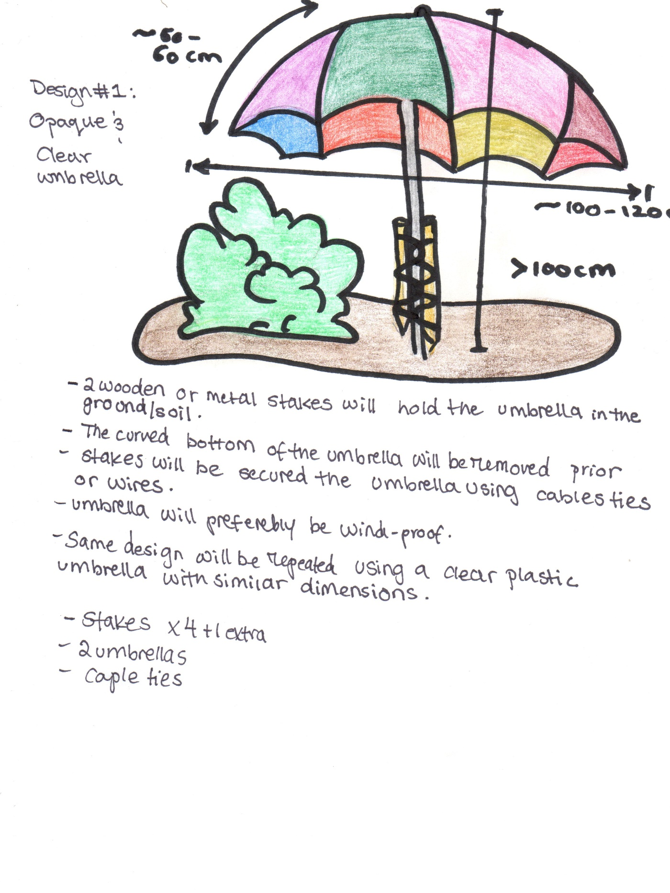

**Figure 2. Umbrella Shelter** One clear that allows light through and one opaque, which limits the amount of light coming through.

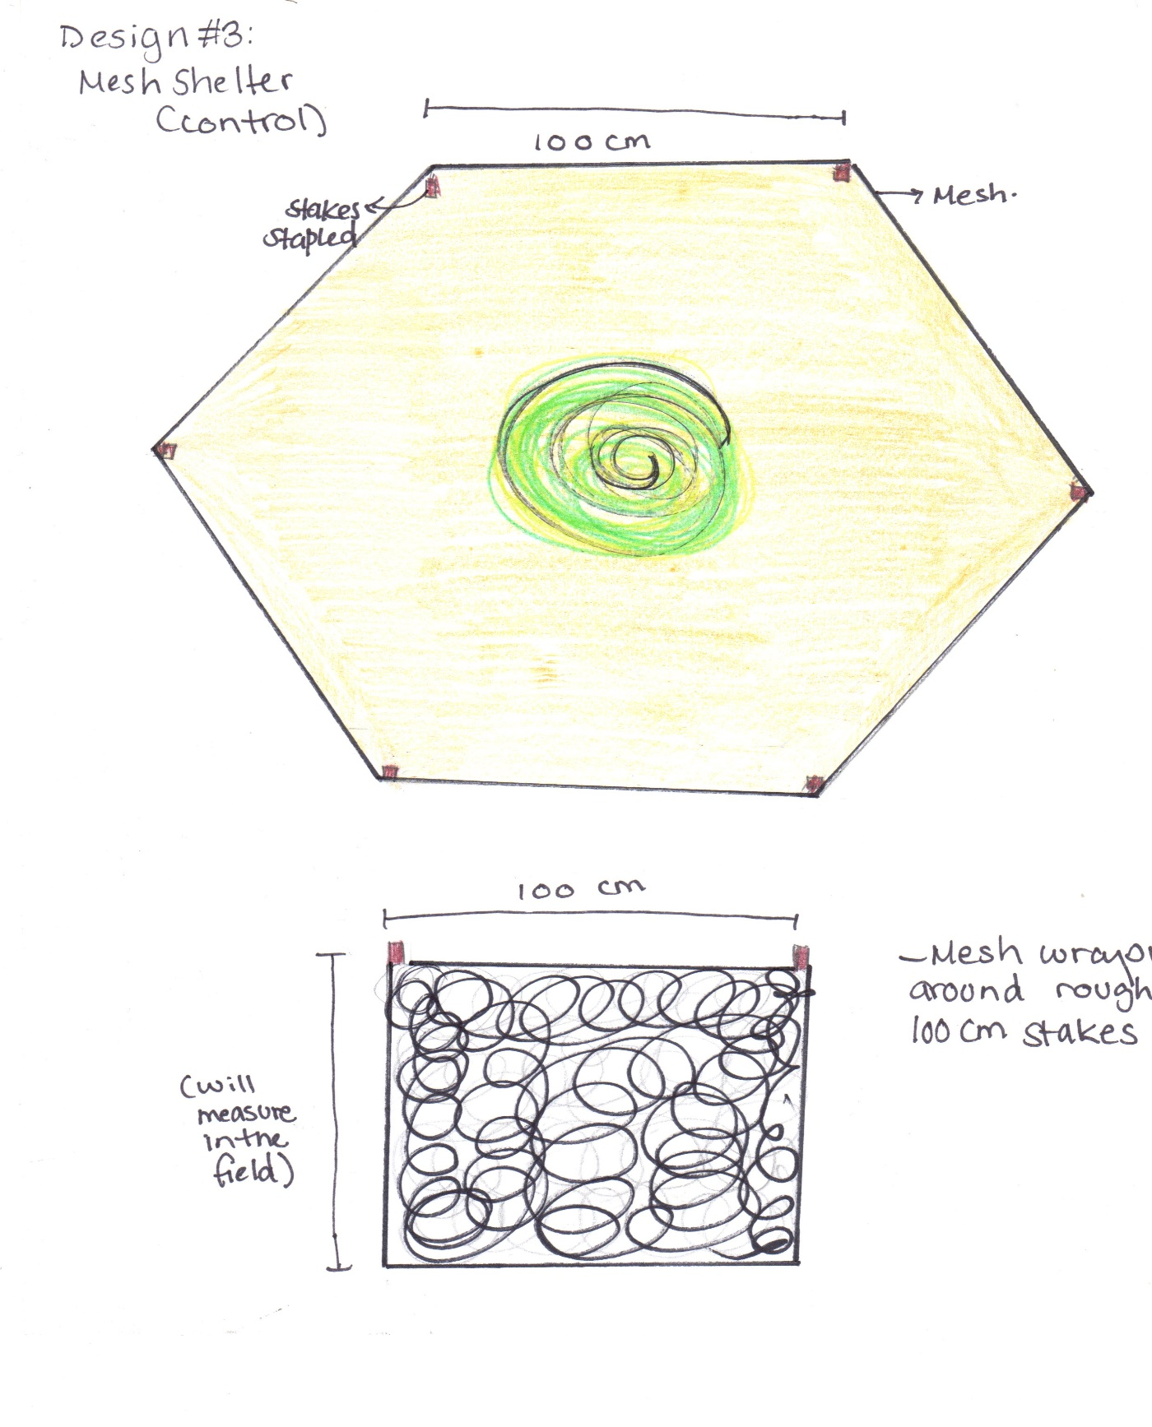

**Figure 3. Mesh shelter**

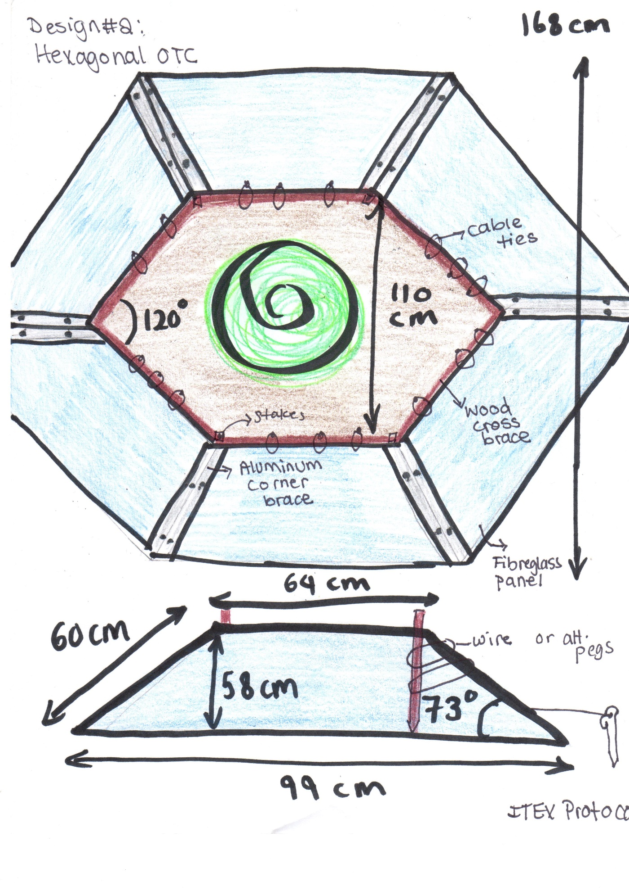

**Figure 4. OTC/Perspex Shelter** This design will be modified to use Perspex instead of fibreglass sides. Because aluminum sides come in a 90° angle, the hexagonal shape will be modified into a square to make assembly easier.

**Work Cited**

1. Bertness, M. D. & Callaway, R. Positive interactions in communities. *Trends Ecol. Evol.* **9**, 191–193 (1994).

2. Maestre, F. T., Callaway, R. M., Valladares, F. & Lortie, C. J. Refining the stress-gradient hypothesis for competition and facilitation in plant communities. *J. Ecol.* **97**, 199–205 (2009).

3. Michalet, R., Le Bagousse-Pinguet, Y., Maalouf, J.-P. & Lortie, C. J. Two alternatives to the stress-gradient hypothesis at the edge of life: the collapse of facilitation and the switch from facilitation to competition. *J. Veg. Sci.* **25**, 609–613 (2014).

4. Lu, R. *et al.* Nurse effects of patch-canopy microhabitats promote herbs community establishment in sandy land. *Ecol. Eng.* **118**, 126–133 (2018).

5. Bertness, M. D. & Leonard, G. H. THE ROLE OF POSITIVE INTERACTIONS IN COMMUNITIES: LESSONS FROM INTERTIDAL HABITATS. *Ecology* **78**, 1976–1989 (1997).

6. Lortie, C. J., Filazzola, A. & Sotomayor, D. A. Functional assessment of animal interactions with shrub-facilitation complexes: a formal synthesis and conceptual framework. *Funct. Ecol.* **30**, 41–51 (2016).

7. Dalsgaard, B. *et al.* Specialization in Plant-Hummingbird Networks Is Associated with Species Richness, Contemporary Precipitation and Quaternary Climate-Change Velocity. *PLoS ONE* **6**, e25891 (2011).

8. Watson, D. M. Fleshing out facilitation - reframing interaction networks beyond top-down versus bottom-up. *New Phytol.* **211**, 803–808 (2016).

9. Filazzola, A. & Lortie, C. J. A systematic review and conceptual framework for the mechanistic pathways of nurse plants: A systematic review of nurse-plant mechanisms. *Glob. Ecol. Biogeogr.* **23**, 1335–1345 (2014).

10. Gómez-Aparicio, L. *et al.* APPLYING PLANT FACILITATION TO FOREST RESTORATION: A META-ANALYSIS OF THE USE OF SHRUBS AS NURSE PLANTS. *Ecol. Appl.* **14**, 1128–1138 (2004).

11. Lortie, C. J., Gruber, E., Filazzola, A., Noble, T. & Westphal, M. The Groot Effect: Plant facilitation and desert shrub regrowth following extensive damage. *Ecol. Evol.* **8**, 706–715 (2018).

12. Bråthen, K. A. & Lortie, C. A portfolio effect of shrub canopy height on species richness in both stressful and competitive environments. *Funct. Ecol.* **30**, 60–69 (2016).

13. Noble, T. J., Lortie, C. J., Westphal, M. & Butterfield, H. S. A picture is worth a thousand data points: an imagery dataset of paired shrub-open microsites within the Carrizo Plain National Monument. *GigaScience* **5**, (2016).

14. Deborah Stout, Jennifer Buck-Diaz, Sara Taylor & Julie M. Evens. *Vegetation mapping and accuracy assessment report for Carrizo Plain National Monument. California Native Plants Society.* (2014).

15. Sawyer, J. O., Keeler-Wolf, T. & Evens, J. *A manual of California vegetation*. (California Native Plant Society Press, 2009).

16. Michelle D. Anderson. *Ephedra nevadensis. In: Fire Effects Information System*. (U.S. Department of Agriculture, Forest Service, Rocky Mountain Research Station, Fire Sciences Laboratory, 2004).

17. Asner, G. P. & Heidebrecht, K. B. Desertification alters regional ecosystem-climate interactions. *Glob. Change Biol.* **11**, 182–194 (2005).

18. Kogan, F. & Guo, W. 2006–2015 mega-drought in the western USA and its monitoring from space data. *Geomat. Nat. Hazards Risk* **6**, 651–668 (2015).

19. MacDonald, G. M. Severe and sustained drought in southern California and the West: Present conditions and insights from the past on causes and impacts. *Quat. Int.* **173**–**174**, 87–100 (2007).

20. Tattini, M. *et al.* Morpho-anatomical, physiological and biochemical adjustments in response to root zone salinity stress and high solar radiation in two Mediterranean evergreen shrubs, Myrtus communis and Pistacia lentiscus. *New Phytol.* **170**, 779–794 (2006).

21. Gibelin, A.-L. & Déqué, M. Anthropogenic climate change over the Mediterranean region simulated by a global variable resolution model. *Clim. Dyn.* **20**, 327–339 (2003).

22. Rosenzweig, C. *et al.* Attributing physical and biological impacts to anthropogenic climate change. *Nature* **453**, 353 (2008).

23. Noonan, M. J. *et al.* In situ behavioral plasticity as compensation for weather variability: implications for future climate change. *Clim. Change* **149**, 457–471 (2018).

24. Berger-Tal, O. *et al.* Integrating animal behavior and conservation biology: a conceptual framework. *Behav. Ecol.* **22**, 236–239 (2011).

25. Trolliet, F., Huynen, M.-C., Vermeulen, C. & Hambuckers, A. Use of camera traps for wildlife studies. A review. *Biotechnol Agron Soc Env.* 9 (2014).

26. Karanth, K. U. Estimating tiger Panthera tigris populations from camera-trap data using capture—recapture models. *Biol. Conserv.* **71**, 333–338 (1995).

27. Dupuis-Desormeaux, M. *et al.* Testing the Prey-Trap Hypothesis at Two Wildlife Conservancies in Kenya. *PLOS ONE* **10**, e0139537 (2015).

28. Bowkett, A. E., Rovero, F. & Marshall, A. R. The use of camera-trap data to model habitat use by antelope species in the Udzungwa Mountain forests, Tanzania. *Afr. J. Ecol.* **46**, 479–487 (2008).

29. Paviolo, A. *et al.* Barriers, corridors or suitable habitat? Effect of monoculture tree plantations on the habitat use and prey availability for jaguars and pumas in the Atlantic Forest. *For. Ecol. Manag.* **430**, 576–586 (2018).

30. Rovero, F. & Marshall, A. R. Camera trapping photographic rate as an index of density in forest ungulates. *J. Appl. Ecol.* **46**, 1011–1017 (2009).

31. Brown, K. W. & Rosenberg, N. J. Shelter-effects on microclimate, growth and water use by irrigated sugar beets in the great plains. *Agric. Meteorol.* **9**, 241–263 (1971).

32. Chiba, M. & Terao, T. Open-Top Chambers with Solar-Heated Air Introduction Tunnels for the High-Temperature Treatment of Paddy Fields. *Plant Prod. Sci.* **17**, 152–165 (2014).

33. Welshofer, K. B., Zarnetske, P. L., Lany, N. K. & Thompson, L. A. E. Open-top chambers for temperature manipulation in taller-stature plant communities. *Methods Ecol. Evol.* **9**, 254–259 (2018).

34. Wilhelm, J., Blackshire, S. & Lanzone, M. Energy-Neutral Data Collection Rate Control for IoT Animal Behavior Monitors. *Appl. Sci.* **7**, 1169 (2017).

35. Moher, D., Liberati, A., Tetzlaff, J., Altman, D. G. & The PRISMA Group. Preferred Reporting Items for Systematic Reviews and Meta-Analyses: The PRISMA Statement. *PLoS Med.* **6**, e1000097 (2009).